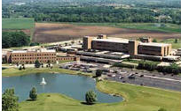
Advocate Good Shepherd Hospital

Located at 450 W. Highway 22
Barrington, Illinois

Advocate Good Shepherd Hospital has the expertise to care for your child’s medical needs. Good Shepherd Hospital has pediatric hospitalists in house 24/7, so there is always a specialist here at the hospital to care for children. The pediatric unit is specially designed to make children feel comfortable. The Good Shepherd Hospital’s Emergency Department is specially equipped and has a special treatment area for children and holds an EDAP (Emergency Department Approved for Pediatrics) certification from the state of Illinois.

Advocate Lutheran General Children's Hospital

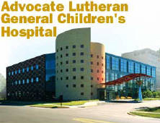
Located at 1775 W. Dempster Street
in Park Ridge, Illinois

Lutheran General Children's Hospital is the premier children's hospital serving the north and northwest metropolitan area. The medical staff features pediatric subspecialists in nearly every medical and surgicalfield. It is one of the largest and most comprehensive children's hospitals in Illinois.

Children's Memorial Hospital
Moving in June to 225 Chicago Avenue
in Chicago

We have courtesy privileges at CMH allowing us easier access to their specialists. In addition to the main hospital and outpatient center in Chicago's Lincoln Park neighborhood, they operate six suburban outpatient centers.

